Use-Case-Model Survey for coursereg_analysis

Issue <1.0>
Revision History
Date | Issue | Description | Author
20/may/99 | 1.0 | Generated from the baselined analysis model. | Rick Bell

Table of Contents
1. Introduction 4
2. Actors 5
2.1 Billing System 5
2.2 Course Catalog 5
2.3 Professor 5
2.4 Registrar 5
2.5 Student 5
2.6 User 5
3. Use Cases 5
3.1 Close Registration 5
3.2 Login 5
3.3 Maintain Professor Information 5
3.4 Maintain Student Information 5
3.5 Register for Courses 5
3.6 Select Courses to Teach 6
3.7 Submit Grades 6
3.8 View Report Card 6

Use-Case-Model Survey for coursereg_analysis

Introduction

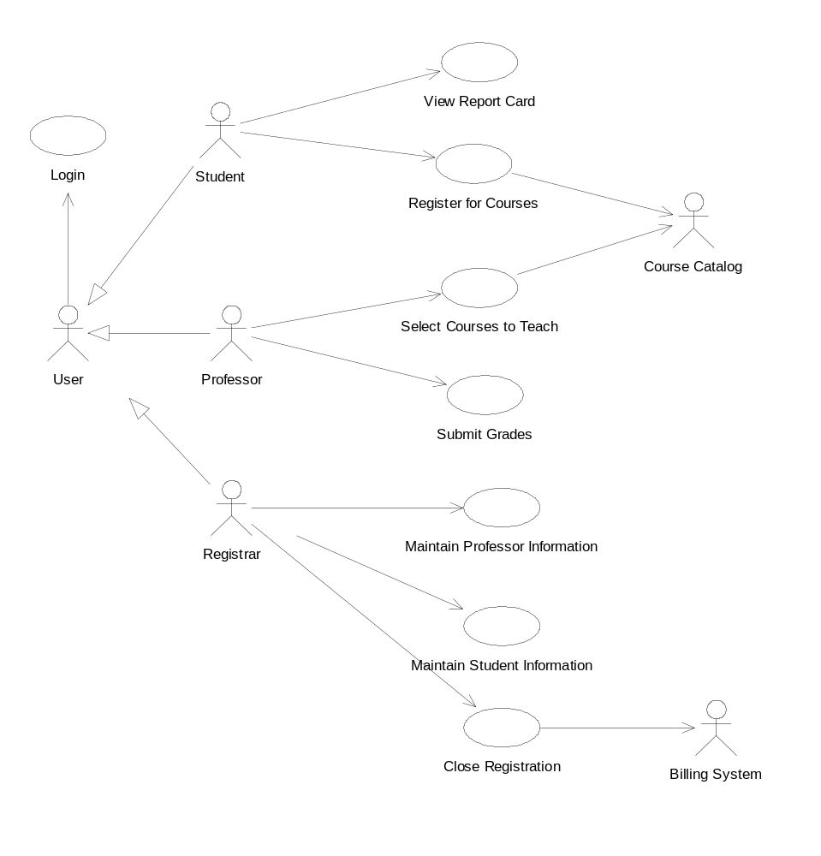
Main

Actors

Billing System

Course Catalog

Professor

Registrar

Student

User

Use Cases

Close Registration

Login
This use case describes how a user logs into the Course Registration System

Maintain Professor Information
This use case allows the registrar to maintain professor information in the registration system. This includes adding, modifying, and deleting professors from the system.

Maintain Student Information
This use case allows the registrar to maintain student information in the registration system. This includes adding, modifying, and deleting students from the system.

Register for Courses
This use case allows a student to register for courses in the current semester. The student can also modify or delete course selections if changes are made within the add/drop period at the beginning of the semester. The Billing System is notified of all registration updates. The Course Catalog provides a list of all the course offerings for the current semester.
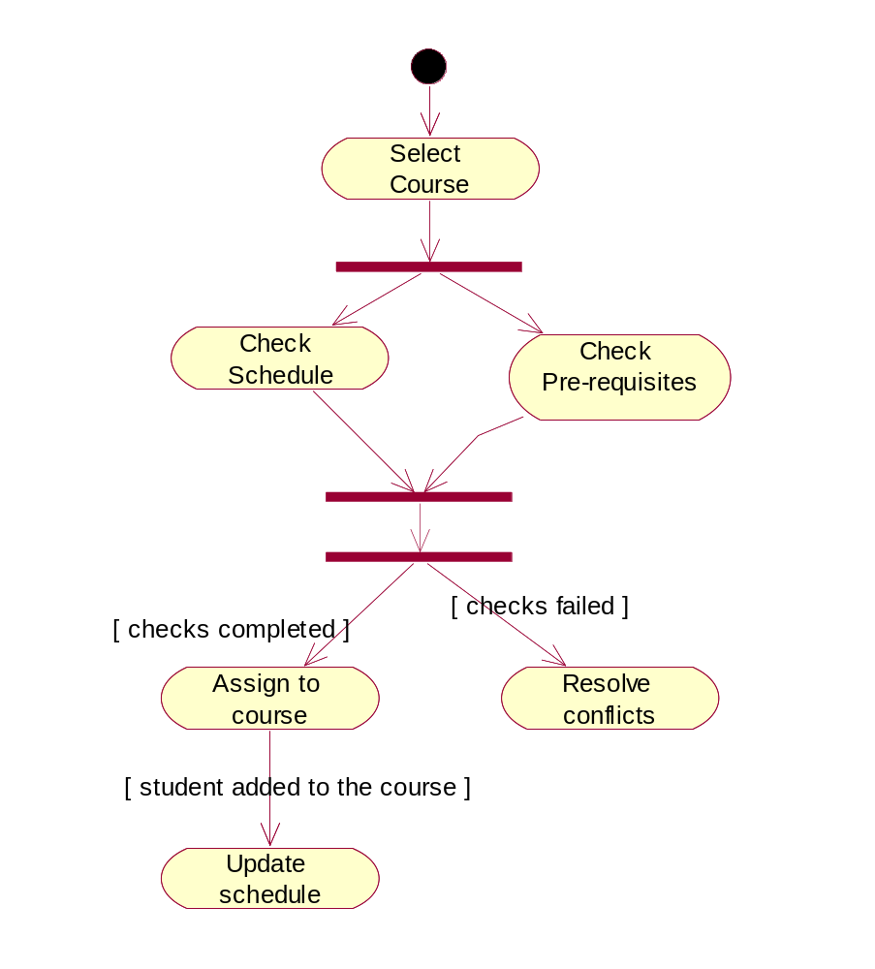
State / Activity diagram: RegisterForCourses

Select Courses to Teach
This use case allows a professor to select the course offerings (date- and time- specific courses will be given) from the course catalog for the courses that he/she is eligible for and wishes to teach in the upcoming semester

Submit Grades
This use case allows a professor to submit student grades for one or more classes completed in the previous semester.

View Report Card
This use case allows a student to view his/her report card for the previously completed semester.

